**Natural Numbers**

Numbers are grouped in to Natural Numbers, Whole numbers, integers, rational numbers and irrational numbers.

**Place Value**

Place value of digits in numbers helps in reading and performing arithmetic operations.  
Example 1:

A place value chart is show below: **56, 894**

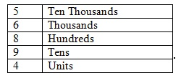  
Hence the amount in words will be, **fifty six thousand, eight hundred and ninety four**.

Example 2:

Use the **875, 351** to answer the questions that follow.

a) What’s the place value of 8  
*ans:* **Hundred Thousands**  
b) Write the number in words  
*ans:* **Eight Hundred and seventy five thousand, three hundred and fifty one**.

Example 3:

Use the **1,001, 001** to answer the questions that follow.

a) Write the amount in words  
*ans:* **One million, One thousand and One**.  
Example 4:  
a) Write in figures: Seven hundred and sixty eight thousand, nine hundred and sixty eight  
*ans:* **768, 968**

**Rounding Off Numbers**

Requires writing a number to a given nearest place value  
Example:  
Consider: 589 371  
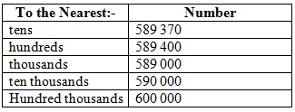

**Even and Odd Numbers**

Even Numbers – exactly divisible by 2 (has remainder 0)  
Examples: 2, 18, 30, 44, 5684  
Odd Numbers – Not exactly divisible by 2 (has a remainder that is not 0)  
Examples: 5, 17, 29, 2589

**Prime Numbers**

These are numbers that have no other divisor except 1 and itself:  
Examples: 2, 3, 5, 7, 11, 19, 23, 29

**Solving word problems**

*Can you solve the problem below?*

Mbuthia sells bananas at his local market. Today, he bought 340 bananas at Ksh. 5 each. During transportation, 17 were badly damaged, 50 were partially damaged so he could sell them at half the price of a good banana. His selling price is Ksh. 20 each good banana. How much profit / loss did he make?